🔹 What is Procedural Programming?
Procedural Programming is a programming style where a program is written as a sequence of step-by-step instructions (procedures or functions).
It focuses on:
- Functions (procedures)
- Step-by-step execution
- Data is passed between functions
Below are simple, clean, exam-ready answers in English based on your notes. You can memorize them directly for good marks.

🔹 What is Object-Oriented Programming (OOP)?
Object-Oriented Programming (OOP) is a programming paradigm where we design software using objects instead of step-by-step procedures.
It focuses on:
- Objects (real-world entities)
- Data (state)
- Behavior (methods)
👉 In OOP, data and functions are combined inside objects.

🔹 Difference between Procedural and OOP Programming
Procedural Programming | Object-Oriented Programming
Focus on functions | Focus on objects
Data and functions are separate | Data and functions are combined
Hard to manage large programs | Easier to manage large programs
Code is less reusable | Code is reusable
Example: function(data) | Example: object.method()
👉 Procedural = “What steps to do”
👉 OOP = “Who does what”

🔹 Why do we need OOP?
We need OOP because in large programs:
- Data and functions become difficult to manage in procedural programming
- Code becomes messy and hard to maintain
- It is difficult to track which function modifies which data
OOP solves these problems by:
- Combining data and behavior in one unit (object)
- Making code more organized and reusable
- Making large systems easier to manage

🔹 What is a Class?
A Class is a blueprint or template used to create objects.
It defines:
- What data an object will have (attributes)
- What actions an object can perform (methods)
👉 A class does not take memory by itself.
Example: Blueprint of a house
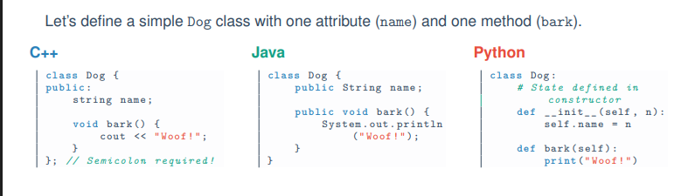
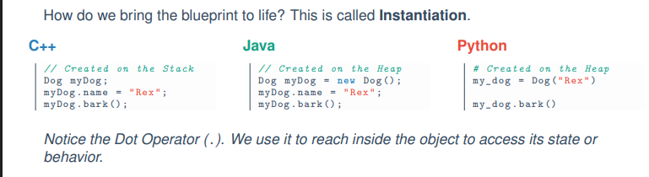

🔹 What is an Object?
An Object is a real instance of a class.
- It is created from a class
- It exists in memory (RAM)
- We can create multiple objects from one class
Example: Actual houses built from the same blueprint

🔹 Difference between Class and Object
Class | Object
Blueprint or design | Real instance
Does not occupy memory | Occupies memory
Logical concept | Physical existence in program
Defines structure | Holds actual data

1.3 State and Behavior (Clean & Exam-Ready)
An Object in Object-Oriented Programming is a software entity that combines two important parts: State and Behavior.

🧠 1. State (Attributes / Data)
State means what the object is or what it knows.
- It represents the data or properties of an object
- It is stored using variables (attributes) inside the object
👉 Example (Dog object):
- name = Bruno
- breed = Husky
- age = 3
- color = Brown
✔ So, state describes the current information of an object.

⚙️ 2. Behavior (Methods / Logic)
Behavior means what the object can do.
- It represents the actions or functions of an object
- It is defined using methods (functions inside the class)
👉 Example (Dog object):
- bark()
- eat()
- sleep()
✔ So, behavior describes the actions or functionalities of an object.

🔹 What is a Custom Data Type?
A Custom Data Type is a user-defined data type created by programmers when built-in data types (like int, float, char, boolean) are not enough to represent real-world objects.

🧠 Simple Explanation:
Computers already provide basic data types:
- int → numbers
- float → decimal numbers
- boolean → true/false
These are called primitive data types.
But in real life, we often deal with complex entities.

🏗️ Why do we need Custom Data Types?
For example, consider a Student.
A student has:
- Name (string)
- ID (int)
- GPA (float)
👉 These values belong to one entity but are of different types.
So, instead of managing them separately, we create a new type called:
👉 Student (Custom Data Type)

💡 Class = Custom Data Type
When we create a class, we are actually defining a new custom data type.

Example:
class Student {
public:
string name;
int id;
float gpa;
};
👉 Here, Student is a custom data type created by the programmer.

